About | Satellite Groups | Events Programme | Magazine | Members | Exhibitions | News | Calendar

Members Gallery
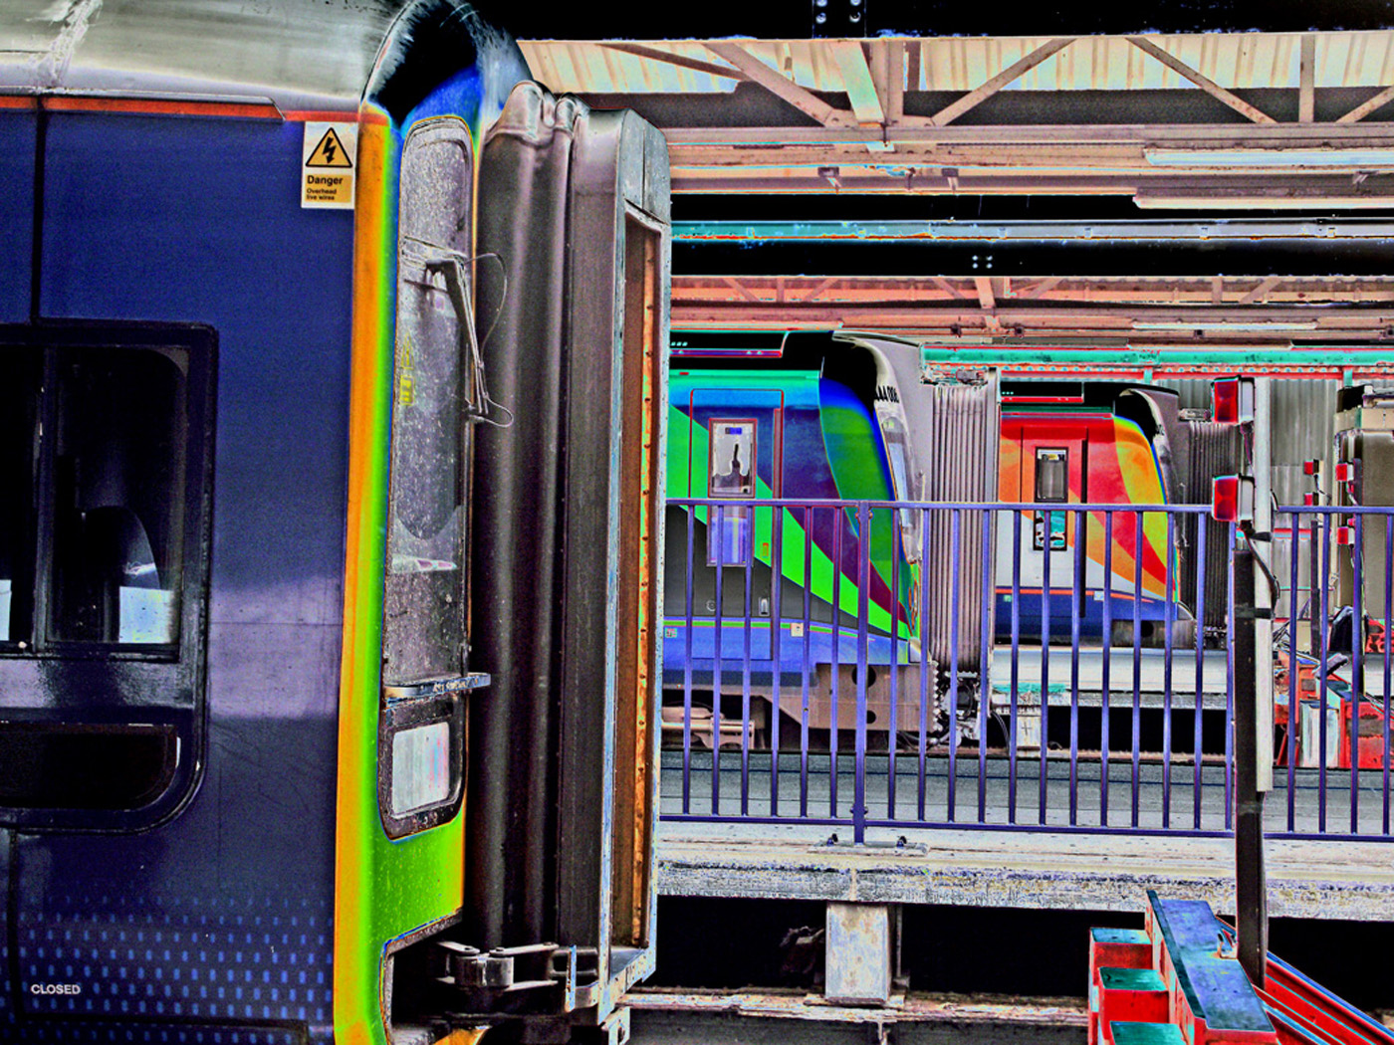  Image © MichaelJDuke. All Rights Reserved. | Michael J Duke  Born in Northampton, Michael spent fifteen years living in Israel. He has been taking photographs since he got his first camera - a Kodak Brownie 127 Box - for his 9th birthday, acting as the family photographic diarist. A number of his images were popular (and several definitely NOT)! In 2000 he joined the Tel Aviv Camera Club, which lead to his first solo exhibition at the Mercaz Bikurei Ha Itim in 2001. During this time Michael also joined the International Freelance Photographers Organization based in the USA. Michael had further solo exhibitions at the Mercaz Bikurei Ha Itim in 2002, in the Holon Municipality in December 2003, and Beit Tammi in Tel Aviv in October 2004.  During 2003-2004, Michael contributed to setting up the Ventures Group of Songwriters, Poets, Artists and Photographers - a group that mixed artistic outputs for cards, CDs, calendars and other products. Michael returned to London in January 2005 and joined the Isle of Wight Photographic Society and HPS. He served the HPS as Programme and Publicity Secretary from 2005-2008 and initiated the group's newsletter (2006) which he continues to edit. Michael has exhibited extensively in North London and at Warwick University, in group expos for both the Hampstead and the Isle of Wight Photographic Societies, in the Isle of Wight celebrating the Ventnor Library 70th Anniversary, and in international salons. He has given numerous talks in London and Warwick.  Michael's website

